

**Solution Design Document**

**CR Sync Master Data from LOS R3**

**PT. Berlian Sistem Informasi**

**Version Control**

|  |  |  |  |
| --- | --- | --- | --- |
| Author | Version | Date | Description |
| Marion Jane | V_1.0 | 9 July 2021 | Draft Version |
| Marion Jane | V_1.1 | 5 August 2021 | Add mapping information |
| Marion Jane | V_1.2 | 20 August 2021 | Add mapping Province for Customer Address |
| Marion Jane | V_1.3 | 6 October 2021 | Update mapping Supplier – VendorParentID |
| Laras Anggit K | V_1.4 | 12 October 2021 | Update mapping |
| Laras Anggit K | V_1.5 | 18 November 2021 | Delete mapping for Product Model Type |

1. **Document Reviewers**

|  |  |  |
| --- | --- | --- |
| Role | Organization | Name |
| Division head ISM | PT. Berlian Sistem Informasi | Valentinus A. Bay |
| Unit head | PT. Berlian Sistem Informasi | Devilosa I Kamal |
| Service manager | PT. Berlian Sistem Informasi | Fajar Solihin Putra |
| Change manager | PT. Berlian Sistem Informasi | Cristin Purnama Sari Kaunang |
| ITD Operation Head | PT. Dipo Star Finance | Ahmad Fikri |
| Superior | PT. Dipo Star Finance | Teddy Faisal |
| Requestor | PT. Dipo Star Finance | Sony Nugraha |

Contents

1. CHANGES 0

1.1. Mapping Field OLSS – LOS R3 0

1.1.1. Customer Personal 0

1.1.2. Customer Corporate 1

1.1.3. Supplier 3

1.1.4. Product 3

1.2. Detail API 4

1.2.1. Customer Personal 4

1.2.2. Customer Corporate 6

1.2.3. Supplier 8

1.2.4. Product 10

1.3. Scheduler Sync 12

1.4. Log of Synchronization 12

1.5. Email Monitoring 15

1.6. Manual Synchronization 16

2. Annexures 18

# CHANGES

# Mapping Field OLSS – LOS R3

# Customer Personal

|  |  |  |  |  |
| --- | --- | --- | --- | --- |
| **OLSS** | | **LOS R3** | | **Remarks** |
| **Field** | **Allow Null** | **API** | **JSON Name** |
| CustomerCode | No | GetListCustByUpdatedDate | CustNo |  |
| CustomerName | No | GetListCustByUpdatedDate | CustName |  |
| Address | Yes | GetListCustAddrByCustId | Addr AreaCode1  AreaCode2  AreaCode3  AreaCode4  City  Zipcode | MrCustAddrTypeCode: “LEGAL” |
| GetProvinceByZipCode | ProvDistrictName |  |
| Telephone | Yes | GetCustPersonalByCustNo | MobilePhnNo1 |  |
| CreateDate | No | GetListCustByUpdatedDate | DtmCrt |  |
| LastModified | Yes | GetListCustByUpdatedDate | DtmUpd |  |
| NPWP | Yes | GetListCustByUpdatedDate | TaxIdNo |  |
| NPWPAddress | Yes | GetListCustAddrByCustId | Addr AreaCode1  AreaCode2  AreaCode3  AreaCode4 City  Zipcode |  |
| GetProvinceByZipCode | ProvDistrictName |  |

Notes:

* For customer address and NPWP address type in LOS R3 still not confirmed yet. LOS R3 needs to confirm the address field when data migration from ACA to LOS R3 and Go Live LOS R3.

Customer Address for personal in OLSS refer to customer’s address in ID Card.

NPWP Address for personal in OLSS refer to customer’s address in NPWP Card.

* For telephone number, OLSS consume Contact Person Phone Number field ini ACA.



In LOS R3 needs to confirm the telephone number field when data migration from ACA to LOS R3 and Go Live LOS R3.

* For LastModified field, LOS R3 will compare last update date for some customer’s database tables and will send the latest update date in JSON DtmUpd.
* Customer Business Sector in OLSS will be NULL and OLSS will send NULL to MFAPPL. This concern has been confirmed to User (Bu Herni) that she will get Customer Business Sector from LOS R3 by email.
* Country information in OLSS’ customer address is from ACA customer’s nationality information, the same information in LOS R3. So OLSS country in customer address will not be mapped.

# Customer Corporate

|  |  |  |  |  |
| --- | --- | --- | --- | --- |
| **OLSS** | | **LOS R3** | | **Remarks** |
| **Field** | **Allow Null** | **API** | **JSON Name** |
| CustomerCode | No | GetListCustByUpdatedDate | CustNo |  |
| CustomerName | No | GetRefMasterByRefMasterTypeCodeAndMasterCode  GetListCustByUpdatedDate | Dscr  CustName | Dscr is for PT, CV, etc  CustName is for customer name: “JAKA TARUB” |
| Address | Yes | GetListCustAddrByCustId | Addr AreaCode1  AreaCode2  AreaCode3  AreaCode4  City  Zipcode | MrCustAddrTypeCode: “BIZ” |
| GetProvinceByZipCode | ProvDistrictName |  |
| Telephone | Yes | GetCustCompanyByCustNo | Phn1 |  |
| CreateDate | No | GetListCustByUpdatedDate | DtmCrt |  |
| LastModified | Yes | GetListCustByUpdatedDate | DtmUpd |  |
| NPWP | Yes | GetListCustByUpdatedDate | TaxIdNo |  |
| NPWPAddress | Yes | GetListCustAddrByCustId | Addr AreaCode1  AreaCode2  AreaCode3  AreaCode4  City  Zipcode | MrCustAddrTypeCode: “LEGAL” |
| GetProvinceByZipCode | ProvDistrictName |  |

Notes:

* For CustomerName field, logic in ACA is if customer type is corporate, then customer name will be put together with customer title.
* For customer address and NPWP address type in LOS R3 still not confirmed yet. LOS R3 needs to confirm the address field when data migration from ACA to LOS R3 and Go Live LOS R3.

Customer Address for corporate in OLSS refer to customer’s address in domicile letter.

NPWP Address for personal in OLSS refer to customer’s address in NPWP Card.

* For telephone number, OLSS consume Contact Person Phone Number field ini ACA.



In LOS R3 needs to confirm the telephone number field when data migration from ACA to LOS R3 and Go Live LOS R3.

* For LastModified field, LOS R3 will compare last update date for some customer’s database tables and will send the latest update date in JSON DtmUpd.
* Customer Business Sector in OLSS will be NULL and OLSS will send NULL to MFAPPL. This concern has been confirmed to User (Bu Herni) that she will get Customer Business Sector from LOS R3 by email.
* Country information in OLSS’ customer address is from ACA customer’s nationality information, the same information in LOS R3. So OLSS country in customer address will not be mapped.
* Change API for get customer name company

# Supplier

|  |  |  |  |  |
| --- | --- | --- | --- | --- |
| **OLSS** | | **LOS R3** | | **Remarks** |
| **Field** | **Allow Null** | **API** | **JSON Name** |
| SupplierGroupCode | No | GetVendorByVendorId | VendorName | Base on VendorParentId |
| MainSupplierCode | No | GetVendorByVendorId | VendorCode | Base on VendorParentId |
| SupplierCode | Yes | GetListVendorByUpdatedDate | VendorCode |  |
| SupplierName | Yes | GetVendorByVendorCode | VendorName |  |
| Address | No | GetVendorAddrByVendorCode | Addr, City |  |
| Telephone | Yes | GetVendorByVendorCode | MobilePhnNo1 |  |
| LastModified | Yes | GetListVendorByUpdatedDate | DtmUpd |  |

Notes:

* For telephone number, OLSS consume Contact Person Phone Number field ini ACA.



In LOS R3 needs to confirm the telephone number field when data migration from ACA to LOS R3 and Go Live LOS R3.

# Product

|  |  |  |  |  |  |
| --- | --- | --- | --- | --- | --- |
| **OLSS** | | | **LOS R3** | | **Remarks** |
| **Table** | **Field** | **Allow Null** | **API** | **JSON Name** |
| PRODUCTBRAND | ProductBrandCode | No | GetAssetMasterById | AssetCode | HierarchyLvl = 1 |
| PRODUCTBRAND | ProductBrandName | No | GetAssetMasterById | AssetName | HierarchyLvl = 1 |
| PRODUCTCATEGORY | ProductCategoryCode | Yes | GetAssetCategoryById | AssetCategoryCode |  |
| PRODUCTCATEGORY | ProductCategory | Yes | GetAssetCategoryById | AssetCategoryName |  |
| PRODUCTMODEL | ProductBrandCode | No | GetAssetMasterById | AssetCode | HierarchyLvl = 1 |
| PRODUCTMODEL | ProductModelCode | No | GetAssetMasterById | AssetCode | HierarchyLvl = 3 |
| PRODUCTMODEL | ProductModelName | Yes | GetAssetMasterById | AssetName | HierarchyLvl = 3 |
| PRODUCTMODEL | ProductModelDescription |  | GetAssetMasterById | AssetCode | AssetCode from ParentID HierarchyLvl = 3 |
| PRODUCTTYPE | ProductType |  | GetAssetTypeById | AssetTypeName |  |

Notes:

* Based on request when do UAT process for not sync data to Model Type

# Detail API

# Customer Personal

|  |  |  |  |
| --- | --- | --- | --- |
| **API ID** | | GetListCustByUpdatedDate | |
| **OLSS TABLE** | | Customer | |
| **DESCRIPTION** | | To get list master data updated as parameter requested | |
| **REQUEST BY** | | OLSS | |
| **RETURNED RESULT BY** | | LOS R3 | |
| **PARAMETERS** | | | | |
| **INPUT** | | **EXPECTED RETURN IF TRUE** | |
| **No** | **Field** | **No** | **Field** | |
| 1 | Start Date | 1 | CustNo | |
| 2 | End Date | 2 | CustId | |
|  |  | 3 | CustName | |
|  |  | 4 | TaxIdNo | |
|  |  | 5 | DtmCrt | |
|  |  | 6 | DtmUpd | |
|  |  |  |  | |
| **REMARKS** |  |  |  | |
| **True Condition:** | |  |  |
|  | There is Code Response Success, Description and Data | | | |
| **False Condition:** | |  |  |
|  | There is Code Response Error, Description Error and Data | | |

|  |  |  |  |
| --- | --- | --- | --- |
| **API ID** | | GetCustPersonalByCustNo | |
| **OLSS TABLE** | | Customer | |
| **DESCRIPTION** | | To get master data based on list | |
| **REQUEST BY** | | OLSS | |
| **RETURNED RESULT BY** | | LOS R3 | |
| **PARAMETERS** | | | | |
| **INPUT** | | **EXPECTED RETURN IF TRUE** | |
| **No** | **Field** | **No** | **Field** | |
| 1 | CustNo | 1 | MobilePhnNo1 | |
|  |  |  |  | |
| **REMARKS** |  |  |  | |
| **True Condition:** | |  |  |
|  | There is Code Response Success, Description and Data | | | |
| **False Condition:** | |  |  |
|  | There is Code Response Error, Description Error and Data | | |

|  |  |  |  |
| --- | --- | --- | --- |
| **API ID** | | GetListCustAddrByCustId | |
| **OLSS TABLE** | | Customer | |
| **DESCRIPTION** | | To get list master data updated as parameter requested | |
| **REQUEST BY** | | OLSS | |
| **RETURNED RESULT BY** | | LOS R3 | |
| **PARAMETERS** | | | | |
| **INPUT** | | **EXPECTED RETURN IF TRUE** | |
| **No** | **Field** | **No** | **Field** | |
| 1 | CustId | 1 | MrCustAddrTypeCode | |
|  |  | 2 | Addr | |
|  |  | 3 | AreaCode1 | |
|  |  | 4 | AreaCode2 | |
|  |  | 5 | AreaCode3 | |
|  |  | 6 | AreaCode4 | |
|  |  | 7 | City | |
|  |  | 8 | Zipcode | |
|  |  |  |  | |
| **REMARKS** |  |  |  | |
| **True Condition:** | |  |  |
|  | There is Code Response Success, Description and Data | | | |
| **False Condition:** | |  |  |
|  | There is Code Response Error, Description Error and Data | | |

|  |  |  |  |
| --- | --- | --- | --- |
| **API ID** | | GetProvinceByZipCode | |
| **OLSS TABLE** | | Customer | |
| **DESCRIPTION** | | To get list master data updated as parameter requested | |
| **REQUEST BY** | | OLSS | |
| **RETURNED RESULT BY** | | LOS R3 | |
| **PARAMETERS** | | | | |
| **INPUT** | | **EXPECTED RETURN IF TRUE** | |
| **No** | **Field** | **No** | **Field** | |
| 1 | Zipcode | 1 | ProvDistrictName | |
|  |  |  |  | |
| **REMARKS** |  |  |  | |
| **True Condition:** | |  |  |
|  | There is Code Response Success, Description and Data | | | |
| **False Condition:** | |  |  |
|  | There is Code Response Error, Description Error and Data | | |

# Customer Corporate

|  |  |  |  |
| --- | --- | --- | --- |
| **API ID** | | GetListCustByUpdatedDate | |
| **OLSS TABLE** | | Customer | |
| **DESCRIPTION** | | To get master data based on list | |
| **REQUEST BY** | | OLSS | |
| **RETURNED RESULT BY** | | LOS R3 | |
| **PARAMETERS** | | | | |
| **INPUT** | | **EXPECTED RETURN IF TRUE** | |
| **No** | **Field** | **No** | **Field** | |
| 1 | Start Date | 1 | CustNo | |
| 2 | End Date | 2 | CustId | |
|  |  | 3 | CustName | |
|  |  | 4 | DtmCrt | |
|  |  | 5 | DtmUpd | |
|  |  | 6 | TaxIdNo | |
|  |  |  |  | |
| **REMARKS** |  |  |  | |
| **True Condition:** | |  |  |
|  | There is Code Response Success, Description and Data | | | |
| **False Condition:** | |  |  |
|  | There is Code Response Error, Description Error and Data | | |

|  |  |  |  |
| --- | --- | --- | --- |
| **API ID** | | GetRefMasterByRefMasterTypeCodeAndMasterCode | |
| **OLSS TABLE** | | Customer | |
| **DESCRIPTION** | | To get master data based on list | |
| **REQUEST BY** | | OLSS | |
| **RETURNED RESULT BY** | | LOS R3 | |
| **PARAMETERS** | | | | |
| **INPUT** | | **EXPECTED RETURN IF TRUE** | |
| **No** | **Field** | **No** | **Field** | |
| 1 | Dscr | 1 | PT | |
|  |  | 2 | CV | |
|  |  | 3 | KOPERASI | |
|  |  | 4 | YAYASAN | |
|  |  | 5 | FIRMA | |
|  |  | 6 | UNIVERSITAS | |
|  |  | 7 | GEREJA | |
|  |  | 8 | OTHERS | |
|  |  | 9 | PERUSAHAAN DAERAH | |
|  |  | 10 | PO | |
|  |  | 11 | PD | |
|  |  | 12 | TOKO | |
|  |  | 13 | UD | |
|  |  | 14 | Gabungan Koperasi | |
|  |  | 15 | Induk Koperasi | |
|  |  | 16 | Koperasi Unit Desa | |
|  |  | 17 | Persero | |
|  |  | 18 | Persekutuan Perdata | |
|  |  | 19 | Perusahaan Umum | |
|  |  | 20 | Primer Koperasi | |
|  |  | 21 | Pusat Koperasi | |
|  |  | 22 | Pusat Koperasi Unit Desa | |
|  |  | 23 | Usaha Dagang | |
|  |  | 24 | Badan Usaha Milik Negara | |
| **REMARKS** |  |  |  | |
| **True Condition:** | |  |  |
|  | There is Code Response Success, Description and Data | | | |
| **False Condition:** | |  |  |
|  | There is Code Response Error, Description Error and Data | | |
| **API ID** | | GetCustCompanyByCustNo | |
| **OLSS TABLE** | | Customer | |
| **DESCRIPTION** | | To get list master data updated as parameter requested | |
| **REQUEST BY** | | OLSS | |
| **RETURNED RESULT BY** | | LOS R3 | |
| **PARAMETERS** | | | | |
| **INPUT** | | **EXPECTED RETURN IF TRUE** | |
| **No** | **Field** | **No** | **Field** | |
| 1 | CustNo | 1 | Phn1 | |
|  |  |  |  | |
| **REMARKS** |  |  |  | |
| **True Condition:** | |  |  |
|  | There is Code Response Success, Description and Data | | | |
| **False Condition:** | |  |  |
|  | There is Code Response Error, Description Error and Data | | |

|  |  |  |  |
| --- | --- | --- | --- |
| **API ID** | | GetListCustAddrByCustId | |
| **OLSS TABLE** | | Customer | |
| **DESCRIPTION** | | To get list master data updated as parameter requested | |
| **REQUEST BY** | | OLSS | |
| **RETURNED RESULT BY** | | LOS R3 | |
| **PARAMETERS** | | | | |
| **INPUT** | | **EXPECTED RETURN IF TRUE** | |
| **No** | **Field** | **No** | **Field** | |
| 1 | CustId | 1 | MrCustAddrTypeCode | |
|  |  | 2 | Addr | |
|  |  | 3 | AreaCode1 | |
|  |  | 4 | AreaCode2 | |
|  |  | 5 | AreaCode3 | |
|  |  | 6 | AreaCode4 | |
|  |  | 7 | City | |
|  |  | 8 | Zipcode | |
|  |  |  |  | |
| **REMARKS** |  |  |  | |
| **True Condition:** | |  |  |
|  | There is Code Response Success, Description and Data | | | |
| **False Condition:** | |  |  |
|  | There is Code Response Error, Description Error and Data | | |

|  |  |  |  |
| --- | --- | --- | --- |
| **API ID** | | GetProvinceByZipCode | |
| **OLSS TABLE** | | Customer | |
| **DESCRIPTION** | | To get list master data updated as parameter requested | |
| **REQUEST BY** | | OLSS | |
| **RETURNED RESULT BY** | | LOS R3 | |
| **PARAMETERS** | | | | |
| **INPUT** | | **EXPECTED RETURN IF TRUE** | |
| **No** | **Field** | **No** | **Field** | |
| 1 | Zipcode | 1 | ProvDistrictName | |
|  |  |  |  | |
| **REMARKS** |  |  |  | |
| **True Condition:** | |  |  |
|  | There is Code Response Success, Description and Data | | | |
| **False Condition:** | |  |  |
|  | There is Code Response Error, Description Error and Data | | |

# Supplier

|  |  |  |  |
| --- | --- | --- | --- |
| **API ID** | | GetListVendorByUpdatedDate | |
| **OLSS TABLE** | | Supplier | |
| **DESCRIPTION** | | To get master data based on list | |
| **REQUEST BY** | | OLSS | |
| **RETURNED RESULT BY** | | LOS R3 | |
| **PARAMETERS** | | | | |
| **INPUT** | | **EXPECTED RETURN IF TRUE** | |
| **No** | **Field** | **No** | **Field** | |
| 1 | Start Date | 1 | VendorId | |
| 2 | End Date | 2 | VendorCode | |
|  |  | 3 | DtmUpd | |
| **REMARKS** |  |  |  | |
| **True Condition:** | |  |  |
|  | There is Code Response Success, Description and Data | | | |
| **False Condition:** | |  |  |
|  | There is Code Response Error, Description Error and Data | | |

|  |  |  |  |
| --- | --- | --- | --- |
| **API ID** | | GetVendorByVendorCode | |
| **OLSS TABLE** | | Supplier | |
| **DESCRIPTION** | | To get list master data updated as parameter requested | |
| **REQUEST BY** | | OLSS | |
| **RETURNED RESULT BY** | | LOS R3 | |
| **PARAMETERS** | | | | |
| **INPUT** | | **EXPECTED RETURN IF TRUE** | |
| **No** | **Field** | **No** | **Field** | |
| 1 | VendorCode | 1 | VendorName | |
|  |  | 2 | VendorCode | |
|  |  | 3 | MobilePhnNo1 | |
|  |  | 4 | VendorParentId | |
| **REMARKS** |  |  |  | |
| **True Condition:** | |  |  |
|  | There is Code Response Success, Description and Data | | | |
| **False Condition:** | |  |  |
|  | There is Code Response Error, Description Error and Data | | |

|  |  |  |  |
| --- | --- | --- | --- |
| **API ID** | | GetVendorAddrByVendorCode | |
| **OLSS TABLE** | | Supplier | |
| **DESCRIPTION** | | To get list master data updated as parameter requested | |
| **REQUEST BY** | | OLSS | |
| **RETURNED RESULT BY** | | LOS R3 | |
| **PARAMETERS** | | | | |
| **INPUT** | | **EXPECTED RETURN IF TRUE** | |
| **No** | **Field** | **No** | **Field** | |
| 1 | VendorCode | 1 | Addr | |
|  |  | 2 | City | |
| **REMARKS** |  |  |  | |
| **True Condition:** | |  |  |
|  | There is Code Response Success, Description and Data | | | |
| **False Condition:** | |  |  |
|  | There is Code Response Error, Description Error and Data | | |

|  |  |  |  |
| --- | --- | --- | --- |
| **API ID** | | GetVendorByVendorId | |
| **OLSS TABLE** | | Supplier | |
| **DESCRIPTION** | | To get VendorName and VendorCode based on VendorParentId | |
| **REQUEST BY** | | OLSS | |
| **RETURNED RESULT BY** | | LOS R3 | |
| **PARAMETERS** | | | | |
| **INPUT** | | **EXPECTED RETURN IF TRUE** | |
| **No** | **Field** | **No** | **Field** | |
| 1 | VendorId | 1 | VendorName | |
|  |  | 2 | VendorCode | |
|  |  |  |  | |
|  |  |  |  | |
| **REMARKS** |  |  |  | |
| **True Condition:** | |  |  |
|  | There is Code Response Success, Description and Data | | | |
| **False Condition:** | |  |  |
|  | There is Code Response Error, Description Error and Data | | |

# Product

|  |  |  |  |
| --- | --- | --- | --- |
| **API ID** | | GetListAssetMasterByUpdatedDate | |
| **OLSS TABLE** | |  | |
| **DESCRIPTION** | | To get master data based on list | |
| **REQUEST BY** | | OLSS | |
| **RETURNED RESULT BY** | | LOS R3 | |
| **PARAMETERS** | | | | |
| **INPUT** | | **EXPECTED RETURN IF TRUE** | |
| **No** | **Field** | **No** | **Field** | |
| 1 | Start Date | 1 | AssetMasterId | |
| 2 | End Date |  |  | |
|  |  |  |  | |
| **REMARKS** |  |  |  | |
| **True Condition:** | |  |  |
|  | There is Code Response Success, Description and Data | | | |
| **False Condition:** | |  |  |
|  | There is Code Response Error, Description Error and Data | | |

|  |  |  |  |
| --- | --- | --- | --- |
| **API ID** | | GetAssetMasterById | |
| **OLSS TABLE** | | Product Brand | |
| **DESCRIPTION** | | To get list master data updated as parameter requested | |
| **REQUEST BY** | | OLSS | |
| **RETURNED RESULT BY** | | LOS R3 | |
| **PARAMETERS** | | | | |
| **INPUT** | | **EXPECTED RETURN IF TRUE** | |
| **No** | **Field** | **No** | **Field** | |
| 1 | AssetMasterId | 1 | AssetCode | |
|  |  | 2 | AssetName | |
|  |  | 3 | HierarchyLvl | |
|  |  |  |  | |
|  |  |  |  | |
|  |  |  |  | |
|  |  |  |  | |
| **REMARKS** |  |  |  | |
| **True Condition:** | |  |  |
|  | There is Code Response Success, Description and Data | | | |
| **False Condition:** | |  |  |
|  | There is Code Response Error, Description Error and Data | | |

|  |  |  |  |
| --- | --- | --- | --- |
| **API ID** | | GetAssetCategoryById | |
| **OLSS TABLE** | | Product Category | |
| **DESCRIPTION** | | To get list master data updated as parameter requested | |
| **REQUEST BY** | | OLSS | |
| **RETURNED RESULT BY** | | LOS R3 | |
| **PARAMETERS** | | | | |
| **INPUT** | | **EXPECTED RETURN IF TRUE** | |
| **No** | **Field** | **No** | **Field** | |
| 1 | AssetCategoryId | 1 | AssetCategoryCode | |
|  |  | 2 | AssetCategoryName | |
|  |  |  |  | |
|  |  |  |  | |
|  |  |  |  | |
|  |  |  |  | |
|  |  |  |  | |
| **REMARKS** |  |  |  | |
| **True Condition:** | |  |  |
|  | There is Code Response Success, Description and Data | | | |
| **False Condition:** | |  |  |
|  | There is Code Response Error, Description Error and Data | | |

|  |  |  |  |
| --- | --- | --- | --- |
| **API ID** | | GetAssetTypeById | |
| **OLSS TABLE** | | Product Type | |
| **DESCRIPTION** | | To get list master data updated as parameter requested | |
| **REQUEST BY** | | OLSS | |
| **RETURNED RESULT BY** | | LOS R3 | |
| **PARAMETERS** | | | | |
| **INPUT** | | **EXPECTED RETURN IF TRUE** | |
| **No** | **Field** | **No** | **Field** | |
| 1 | AssetTypeId | 1 | AssetTypeName | |
|  |  |  |  | |
| **REMARKS** |  |  |  | |
| **True Condition:** | |  |  |
|  | There is Code Response Success, Description and Data | | | |
| **False Condition:** | |  |  |
|  | There is Code Response Error, Description Error and Data | | |

|  |  |  |  |
| --- | --- | --- | --- |
| **API ID** | | GetAssetMasterAttrContentForAssetMaster | |
| **OLSS TABLE** | | Product Model | |
| **DESCRIPTION** | | To get list master data updated as parameter requested | |
| **REQUEST BY** | | OLSS | |
| **RETURNED RESULT BY** | | LOS R3 | |
| **PARAMETERS** | | | | |
| **INPUT** | | **EXPECTED RETURN IF TRUE** | |
| **No** | **Field** | **No** | **Field** | |
| 1 | AssetMasterId | 1 | AttrContent | |
| 2 | AssetAttrId |  |  | |
|  |  |  |  | |
| **REMARKS** |  |  |  | |
| **True Condition:** | |  |  |
|  | There is Code Response Success, Description and Data | | | |
| **False Condition:** | |  |  |
|  | There is Code Response Error, Description Error and Data | | |

# Scheduler Sync

Same as sync with ACA, LOS R3 will sync data every 15 minutes to OLSS. In meeting July 5, 2021, LOS R3 team were agree that they will try to sync every 15 minutes and see the performance. If the performance is not good, we will set longer time sync every +- 1 hour and inform user to use button **Sync** if there is customer/ supplier urgent.

# Log of Synchronization

There will be log file to monitor the synchronization per day. Per hit API, log will generate 3 rows detail for Customer, Product, and Supplier.

**Example of Customer row log:**

<SUCCESS LogInfo = xmlns="7/12/2021 8:00:34 AM"><Engine = >OLSS Auto Sync</Engine = ><StartSync = >07/12/2021 08:00:29.626</StartSync = ><EndSync = >07/12/2021 08:00:34.466</EndSync = ><TotalInsert = >3</TotalInsert = ><TotalSelect = >20</TotalSelect = ><TotalUpdate = >17</TotalUpdate = ><MasterName = >Customer</MasterName = ></SUCCESS LogInfo = >

**Example of Product row log:**

<SUCCESS LogInfo = xmlns="7/12/2021 8:00:34 AM"><Engine = >OLSS Auto Sync</Engine = ><StartSync = >07/12/2021 08:00:34.482</StartSync = ><EndSync = >07/12/2021 08:00:34.546</EndSync = ><TotalInsert = >0</TotalInsert = ><TotalSelect = >0</TotalSelect = ><TotalUpdate = >0</TotalUpdate = ><MasterName = >Product</MasterName = ></SUCCESS LogInfo = >  
  
**Example of Supplier row log:**

<SUCCESS LogInfo = xmlns="7/12/2021 8:00:34 AM"><Engine = >OLSS Auto Sync</Engine = ><StartSync = >07/12/2021 08:00:34.546</StartSync = ><EndSync = >07/12/2021 08:00:34.562</EndSync = ><TotalInsert = >0</TotalInsert = ><TotalSelect = >0</TotalSelect = ><TotalUpdate = >0</TotalUpdate = ><MasterName = >Supplier</MasterName = ></SUCCESS LogInfo =

**Example of error in Customer log:**<ERROR LogInfo = xmlns="7/15/2021 10:44:16"><Error Message = >Customer System.Data.SqlClient.SqlException (0x80131904): A network-related or instance-specific error occurred while establishing a connection to SQL Server. The server was not found or was not accessible. Verify that the instance name is correct and that SQL Server is configured to allow remote connections. (provider: SQL Network Interfaces, error: 26 - Error Locating Server/Instance Specified)  
at System.Data.SqlClient.SqlInternalConnectionTds..ctor(DbConnectionPoolIdentity identity, SqlConnectionString connectionOptions, SqlCredential credential, Object providerInfo, String newPassword, SecureString newSecurePassword, Boolean redirectedUserInstance, SqlConnectionString userConnectionOptions, SessionData reconnectSessionData, DbConnectionPool pool, String accessToken, Boolean applyTransientFaultHandling, SqlAuthenticationProviderManager sqlAuthProviderManager)  
at System.Data.SqlClient.SqlConnectionFactory.CreateConnection(DbConnectionOptions options, DbConnectionPoolKey poolKey, Object poolGroupProviderInfo, DbConnectionPool pool, DbConnection owningConnection, DbConnectionOptions userOptions)  
at System.Data.ProviderBase.DbConnectionFactory.CreatePooledConnection(DbConnectionPool pool, DbConnection owningObject, DbConnectionOptions options, DbConnectionPoolKey poolKey, DbConnectionOptions userOptions)  
at System.Data.ProviderBase.DbConnectionPool.CreateObject(DbConnection owningObject, DbConnectionOptions userOptions, DbConnectionInternal oldConnection)  
at System.Data.ProviderBase.DbConnectionPool.UserCreateRequest(DbConnection owningObject, DbConnectionOptions userOptions, DbConnectionInternal oldConnection)  
at System.Data.ProviderBase.DbConnectionPool.TryGetConnection(DbConnection owningObject, UInt32 waitForMultipleObjectsTimeout, Boolean allowCreate, Boolean onlyOneCheckConnection, DbConnectionOptions userOptions, DbConnectionInternal&amp; connection)  
at System.Data.ProviderBase.DbConnectionPool.TryGetConnection(DbConnection owningObject, TaskCompletionSource`1 retry, DbConnectionOptions userOptions, DbConnectionInternal&amp; connection)  
at System.Data.ProviderBase.DbConnectionFactory.TryGetConnection(DbConnection owningConnection, TaskCompletionSource`1 retry, DbConnectionOptions userOptions, DbConnectionInternal oldConnection, DbConnectionInternal&amp; connection)  
at System.Data.ProviderBase.DbConnectionInternal.TryOpenConnectionInternal(DbConnection outerConnection, DbConnectionFactory connectionFactory, TaskCompletionSource`1 retry, DbConnectionOptions userOptions)  
at System.Data.ProviderBase.DbConnectionClosed.TryOpenConnection(DbConnection outerConnection, DbConnectionFactory connectionFactory, TaskCompletionSource`1 retry, DbConnectionOptions userOptions)  
at System.Data.SqlClient.SqlConnection.TryOpenInner(TaskCompletionSource`1 retry)  
at System.Data.SqlClient.SqlConnection.TryOpen(TaskCompletionSource`1 retry)  
at System.Data.SqlClient.SqlConnection.Open()  
at SyncOLSSMaster100.DataOLSSTableAdapters.Tb_M_JsTableAdapter.DateByJobNm() in d:\Firmansyah\Source Code\AzureDevOps\PTBSI\SyncACA\OLS_20210621_S0237590\SyncOLSSMaster\DataOLSS.Designer.cs:line 31361  
at SyncOLSSMaster100.process.SyncACACust(DateTime sSync) in d:\Firmansyah\Source Code\AzureDevOps\PTBSI\SyncACA\OLS_20210621_S0237590\SyncOLSSMaster\Program.cs:line 45  
ClientConnectionId:00000000-0000-0000-0000-000000000000  
Error Number:-1,State:0,Class:20</Error Message = ></ERROR LogInfo = >

This log can be find at:

# Email Monitoring

This email monitoring created to monitor API activities. It will be built under email server smtp.office365.com port 587 (recommended) or port 25. There are 2 types of email monitoring:

1. Email monitoring for API success.

For make sure that API sync running well, system will send email monitoring for API success at 4 AM, 6 AM, 12 PM and 8 PM every day. The email schedule is same as monitoring OLSS login. the email example:

**Subject:**

SUCCESS MONITORING API

**Body email:**

Dear ALL,

This is summary of data synced at 12 July 2021 4.00:

Customer: Total Select 50, Total Update 10, Total Insert 40

Supplier: Total Select 15, Total Update 15, Total Insert 0

Product: Total Select 1, Total Update 0, Total Insert 1

Best Regards,   
  
OLS.Support   
P: 021 - 4786 7575 ext.6098   
E: [ols.support@dipostar.com](mailto:ols.support@dipostar.com)

1. Email monitoring for API failed.

System will sent email Failed if:

* + LOS R3 send response code error (will be defined).
  + Error in OLSS based on windows exception.

Email example:

**Subject:**

FAILED API DETECTED!

**Body email:**

There is an error send from LOS R3 with code …, description:

“…”

Please check the synchronize.

Best Regards,   
OLS.Support   
P: 021 - 4786 7575 ext.6098   
E: [ols.support@dipostar.com](mailto:ols.support@dipostar.com)

These emails will be sent to:

[laras.kinanti@bsi.co.id](mailto:laras.kinanti@bsi.co.id)

[firmansyah@bsi.co.id](mailto:firmansyah@bsi.co.id)

[Sony.Nugraha@dipostar.com](mailto:Sony.Nugraha@dipostar.com)

To add email recipient and change body email it can be set at file config. For example, email monitoring config is:

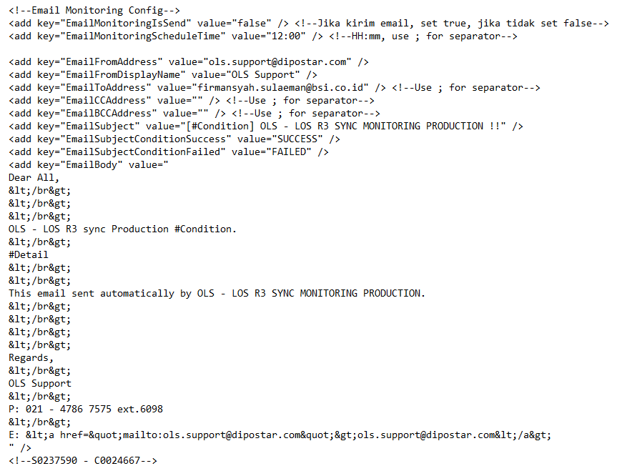

# Manual Synchronization

If API failed, the data between the time should be re-synced. Or maybe we need to synchronize old data. To sync data with determined time, there is manual synchronization which we can change the date as we need. To do manual sync, open this configuration in ….

1. Change **false** value to **true** in key RunManualCustomer and/or RunManualSupplier and/or RunManualProduct based on data needed (if you need Customer data, you can only change value in RunManualCustomer).
2. Save and exit the notepad.
3. Run the application.

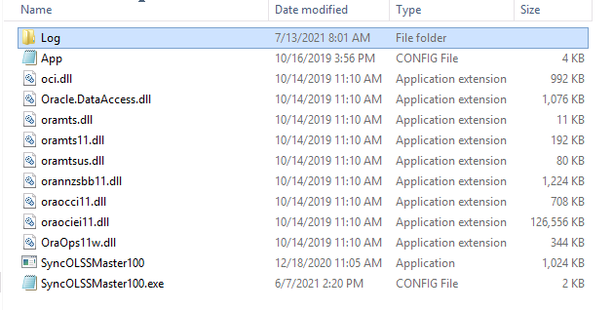

1. 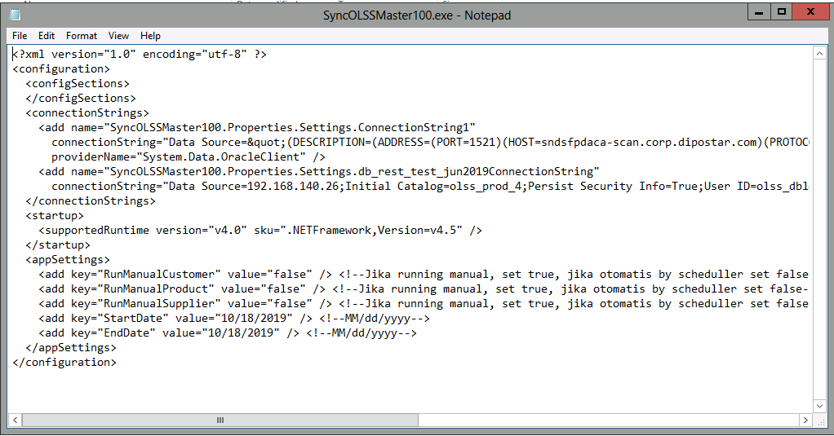Change the value to **false** again. Please remember to do this step. If not, automatic sync will be stop.

*Exampe of existing manual synchronization ACA – OLSS*

# Annexures

|  |  |  |
| --- | --- | --- |
| **Sr No** | **Document Name** | **Attachment/Path** |
| **1** | **BRD CR Sync Master Data from LOS R3** |  |
| **2** | **RFC CR Sync Master Data from LOS R3** |  |